Programme Erasmus+
2021-1-IT01-KA220-VET-000034836 Erasmus+ KA220 - VET - Cooperation partnerships in vocational education and training

DIGICULT
Cultural Heritage:
a source of resilience and learning through digital education

PR - TITLE

Guidelines for the DigiCult Game (PR3)

EN

Elaborated by FAI and VsI “eMundus”

Date 06/27/2024

digicult game
DigiCult Game is the third result of the project “Cultural Heritage: a source of resilience and learning through digital education” (DigiCult). This educational game will give a chance to explore the cultures in a gamified way.
The game is quiz format, which includes questions to be answered in order to test the users. It also includes points and certificates to motivate them. Questions are displayed in text, images, which should be answered by choosing correct ones, drag and drop or entering the correct words. The game is released in a nonlinear form so users can jump from stage to stage.
In order to start the game please follow further steps:
- Access the Game:
Visit DigiCult Game website www.digicultgame.eu

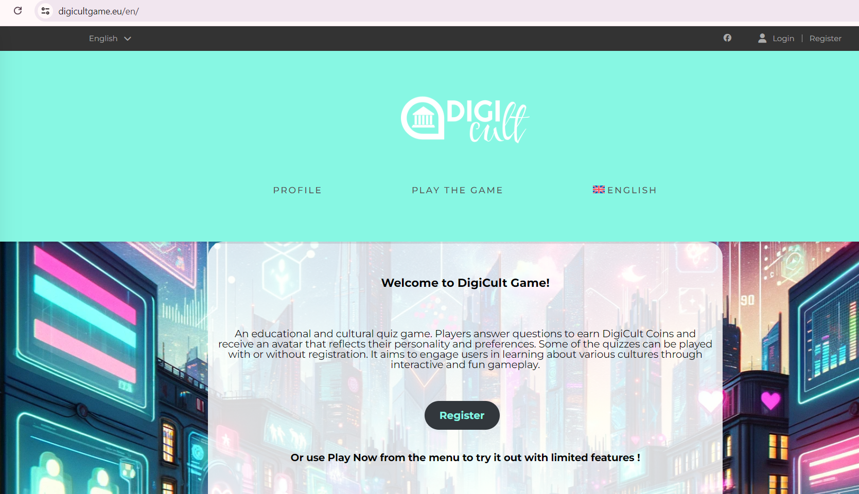

- Language:
Choose the language in the menu (English, Greek, Italian, Lithuanian, Swedish, Croatian).
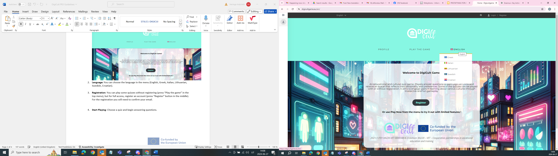

- Start playing – two options:

- Without Registration:
You can play some quizzes without registering (press “Play the game” in the top menu). The quizzes that are available without registration are: Walk in my shoes, Typical foods, Music Era, Sports and games.
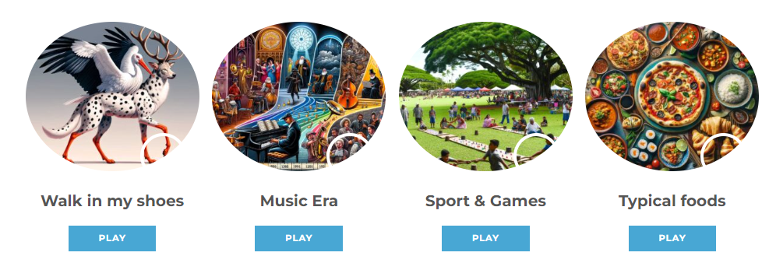

- With registration:
Register an account for full access (press “Register” button in the middle). For the registration you will need to confirm your email.

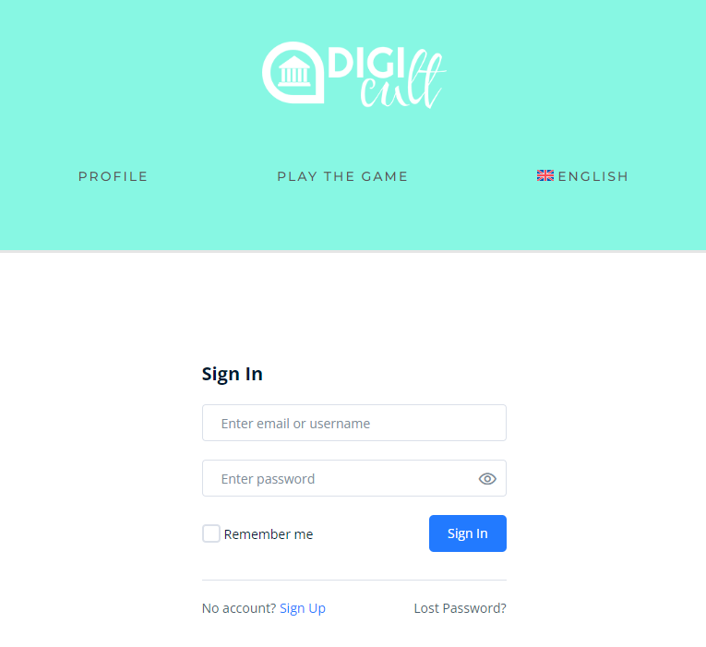

- “Walk in my shoes”: put yourself in the shoes of cultural professionals (you can access this initial game with or without registration):
Try to put yourself in the shoes of professionals who work in the cultural sector. Answer the three quizzes that invite you to identify yourself as: influencer, tour guide, event organizer. Try to understand how they behave and what their personal attitudes are in relation to their profession.
Each professional is personified by a different version of the “Moufwoldal”: a cool mash-up of the iconic animals from DigiCult project partner countries: the Cypriot Mouflon, the Italian Wolf, the Irish Red Deer, the Lithuanian White Stork, the Swedish Moose, and the Croatian Dalmatian Dog.

“Moufwoldal” embodies digital innovation and celebrates the natural heritage of each partner country.

Once this first quiz is completed the user receives 100 Digicult coins to start playing.

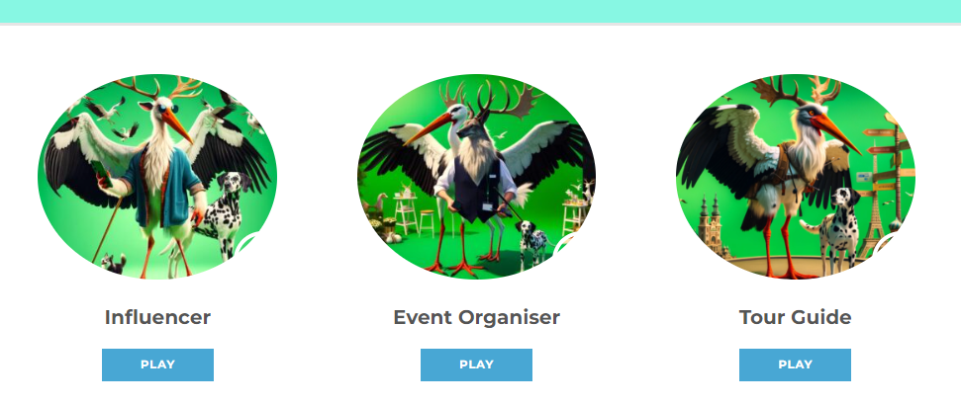

- Start Playing: Choose a quiz and begin answering questions. Engage with various cultural questions and learn interactively.

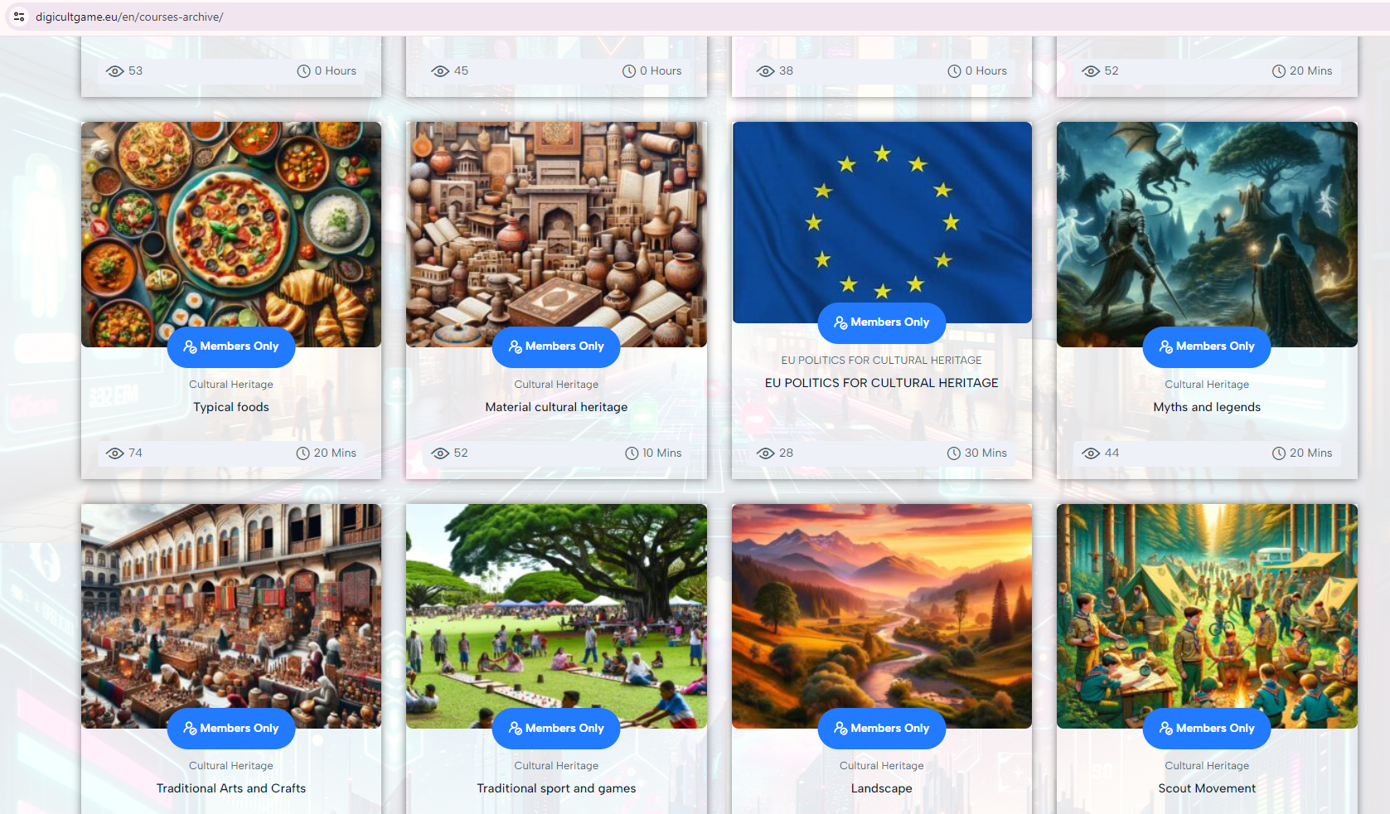

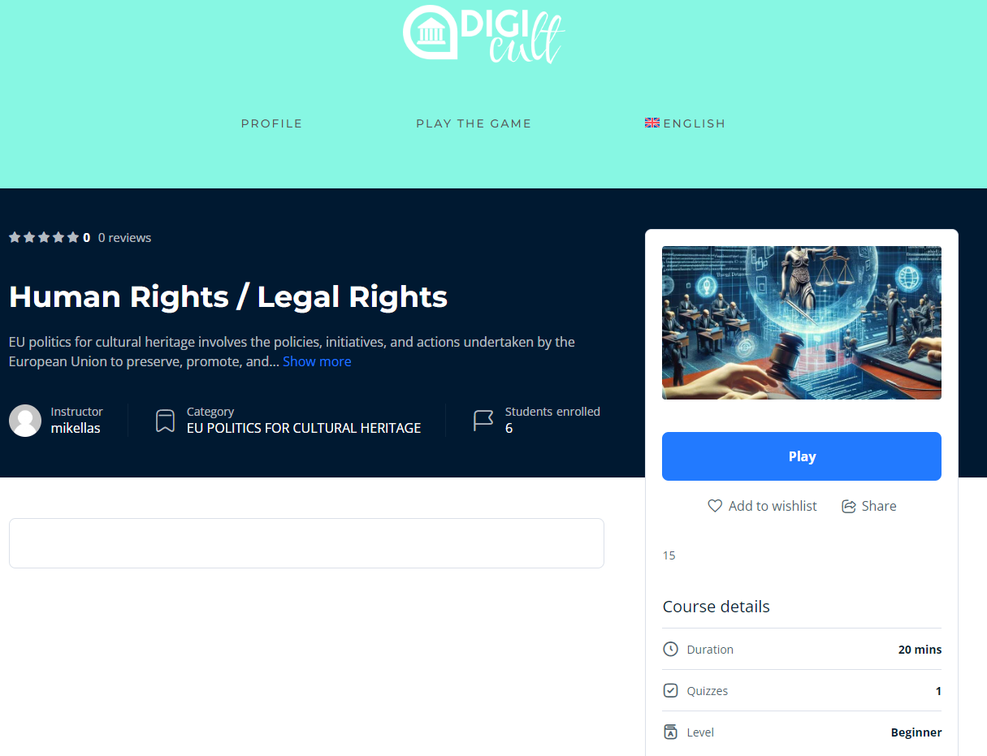

- Questions: please find hereby some questions examples:

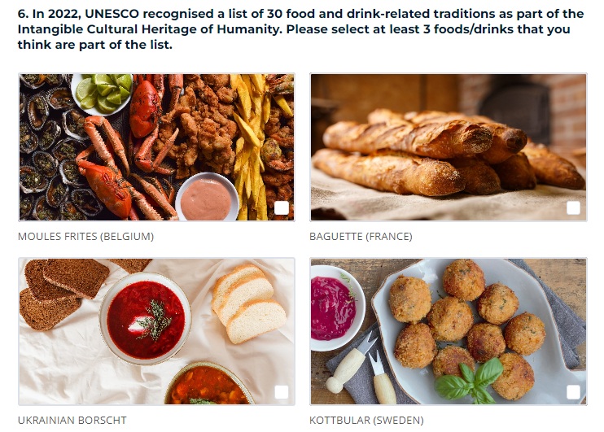

- Get a certificate: Once you successfully complete one quiz, you receive a certificate that can be found also in the “enrolled courses section”:

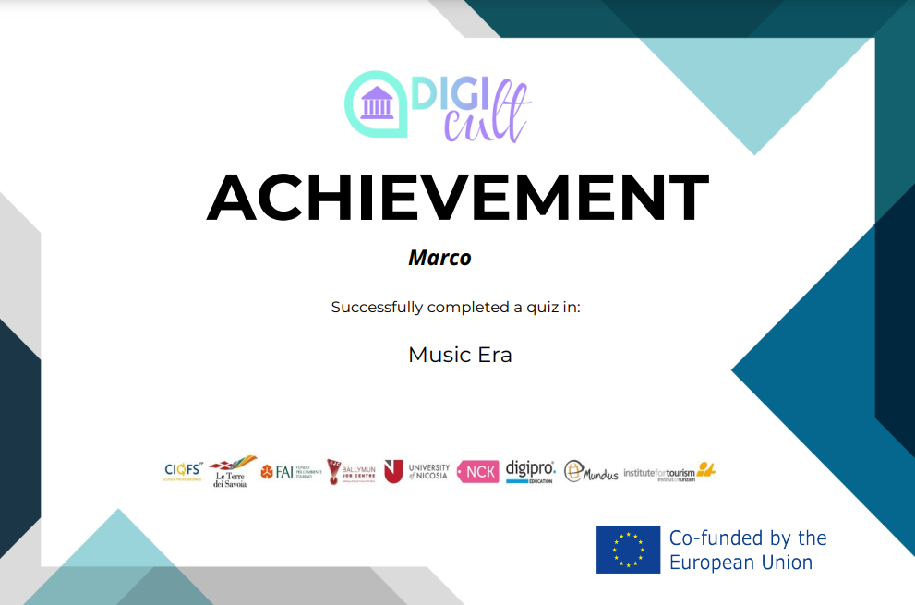

- Earn Coins: Correct answers earn you DigiCult Coins. You can spend them on the quizzes which are closed in the beginning.
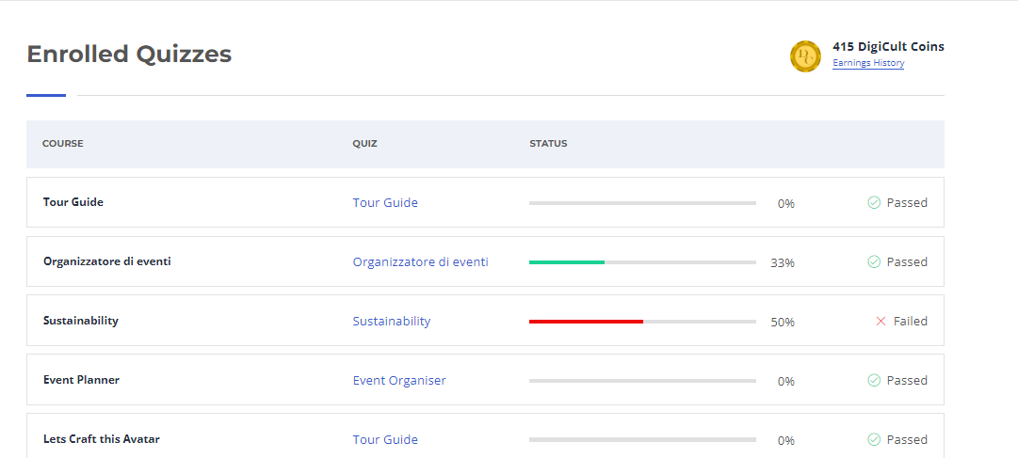
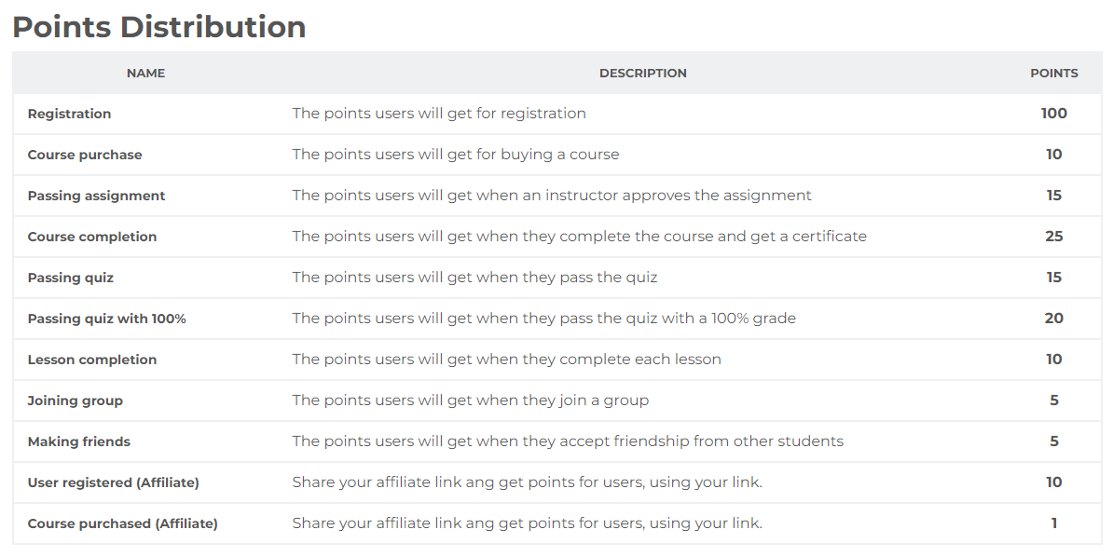

- Profile: you can change information of your account.

